Lab problems Simple Linear Regression
- Which line is the ‘best-fitting’ line? (you can use LAB_question1_data.SAV to help guide you through this question).
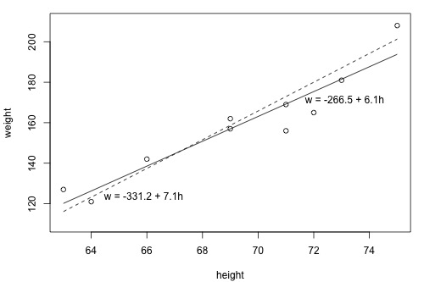
Below are the height (h = X) and weight (w = Y) points for each of the two lines presented in the graph above along with the predicted value of Y. First verify that the predicted value is correct for each line given that height is 69. Then, complete the chart by filling in the values. Finally, determine which line fits these data the best?

Equation 1: dashed line
i | $$x_{i}$$ | $$y_{i}$$ | $${\hat{y}}_{i}$$ | ($y_{i}- {\hat{y}}_{i})$ | $${(y_{i}- {\hat{y}}_{i})}^{2}$$
1 | 63 | 127 | 116.1 | 10.9 | 118.81
2 | 64 | 121 | 123.2 | -2.2 | 4.84
3 | 66 | 142 | 137.4 | 4.6 | 21.16
4 | 69 | 157 | 158.7 | -1.7 | 2.89
5 | 69 | 162 | 158.7 | 3.3 | 10.89
6 | 71 | 156 | 172.9 |  | 285.61
7 | 71 | 169 | 172.9 | -3.9 | 15.21
8 | 72 | 165 | 180 | -15 | 225
9 | 73 | 181 |  | -6.1 | 37.21
10 | 75 | 208 | 201.3

Equation 2: solid line
i | $$x_{i}$$ | $$y_{i}$$ | $${\hat{y}}_{i}$$ | ($y_{i}- {\hat{y}}_{i})$ | $${(y_{i}- {\hat{y}}_{i})}^{2}$$
1 | 63 | 127 | 120.14 | 6.8612 | 47.076
2 | 64 | 121 | 126.28 | -5.276 | 27.84
3 | 66 | 142 |  | 3.4484 | 11.891
4 | 69 | 157 | 156.96 |  | 0.001
5 | 69 | 162 | 156.96 |  | 25.357
6 | 71 | 156 | 169.24 | -13.24 | 175.29
7 | 71 | 169 | 169.24 | -0.24 | 0.057
8 | 72 | 165 | 175.38 | -10.38
9 | 73 | 181 | 181.52 | -0.515 | 0.265
10 | 75 | 208 | 193.79 | 14.21 | 201.92

The line corresponding to the (dashed/solid) line is the equation that minimizes the sum of squared errors.

- Below is the partial output from the regression analysis for the best fitting line above and the descriptive statistics for x and y (mean, standard deviation, and correlation).
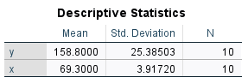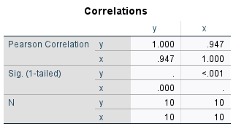
Model Summary
Model | R | R Square | Adjusted R Square | Std. Error of the Estimate
1 | .947ª |  | .884 | 8.64137
a. Predictors: (Constant), x

ANOVAª
Model |  |  | Sum of Squares |  | df |  | Mean Square | F |  | Sig.
1 | Regression |  | 5202.214 |  | 1 |  | 5202.214 | 69.666 |  | <.001^{b}
1 | Residual |  |  |  | 8 |  | 74.673
1 | Total |  | 5799.600 |  | 9
a. Dependent Variable: y
b. Predictors: (Constant), x
Coefficientsª
Model |  | Unstandardized Coefficients |  |  |  | Standardized Coefficients |  |  | t |  | Sig.
 |  | B |  | Std. Error |  | Beta
1 | (Constant) |  |  | 51.032 |  |  |  |  | -5.223 |  | <.001
1 | x |  |  | .735 |  | .947 |  |  | 8.347 |  | <.001
a. Dependent Variable: y

  - Verify that the sum of squares residual error (SS residual error) in the output corresponds to the figure you obtained in question 1.
  - Interpret the correlation coefficient for the two variables
  - Fill in the missing entries for the table.
  - Interpret R-squared
  - Interpret the intercept and slope coefficients for the model.
  - What is the predicted value when x = 0? Does this make sense? Why/Why not?

- For this question we will use data created by randomly sampling 400 elementary schools from the California Department of Education’s API 2000 dataset. This data file contains a measure of school academic performance as well as other attributes of the elementary schools, such as, class size, enrollment, poverty, etc. The data are collected at the school level, i.e., the unit of analysis is the school.
  - State how your analysis of the relationship between academic achievement and free/reduced lunch may be limited by data collected at the school level. How might this impact your regression results?
  - What is your expectation for how these data may be related?
  - Report the descriptive statistics (mean, sd, min, max) for the two variables
  - Report the correlation coefficient for the two variables and make a scatterplot of the variables using SPSS, Do you notice any violations in the assumptions for linear regression?
  - Perform a regression analysis that explores the relationship between academic performance for the year 2000 (api2000) and percent of students in the school receiving free or reduced lunch (meals). Save the standardized residuals and include a plot of the standardized predicted values versus residuals in our output.
    - Are you concerned with violations of linear regression assumptions?
    - Interpret the beta coefficients
    - How much variation in school performance is explained by the percentage of students who have free or reduced lunch?
    - Create a simple boxplot of standardized residuals by District number. Are you concerned about violations of independence? Why/why not?
    - Oftentimes it is more descriptive to use a meaningful measure for the independent variable by which to calculate a change in the dependent variable.
      - Calculate the change in academic performance for a standard deviation change in the percentage of students on free and reduced lunch.
      - What is the predicted achievement score for a standard deviation change in free and reduced lunch?
      - Verify that SSR = R-squared x SST
      - Verify that $r$ $×\frac{S_{y}}{S_{x}}$ = $b_{1}$
      - In words, write out all possible decisions about the inference for $b_{1}$ (i.e, Type I, II errors and the two correct decisions)

